Girls

Night In

Donation Form

Be a PINK Ambassador – gather the girls!
Our goal during 2019 Breast Cancer Awareness Month is to raise $250,000.
All funds raised support our Equal Access Fund and our Prevention and Early Detection Programmes.
The Equal Access Fund provides financial support for uninsured & underinsured men and women to receive recommended cancer screening and diagnostic services available at Bermuda Cancer and Health Centre.

Did you know that a donation of $326 will pay for a mammogram for someone who cannot afford one!

NAME | EMAIL | DONATION AMOUNT | RECEIVED
 |  | TOTAL | $

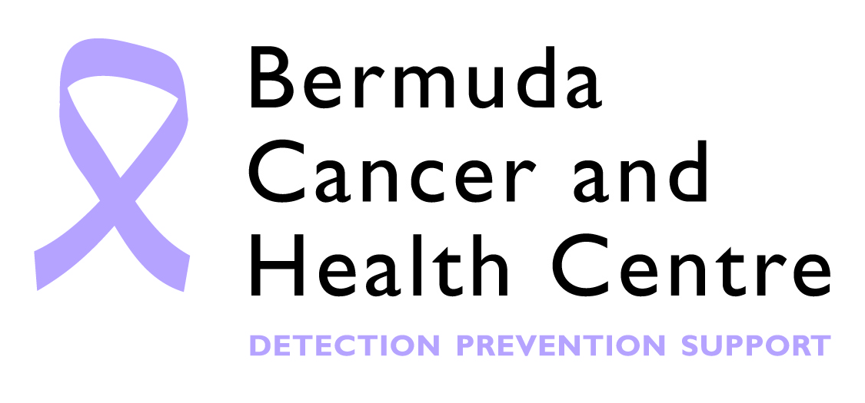
Two simple methods to donate the funds you have raised:
- Online – HSBC/Bank of Bermuda, Account Number: 006-048482-011
- Cheque - made payable to Bermuda Cancer and Health Centre, P.O. Box HM1562, Hamilton HM FX Bermuda
Please submit completed donation forms either by fax to 236-0080 or email events@chc.bm.

